Database Tuning
CS5226
Lab 2

A0079953L – LEE ZHONG DE ROLLEI

TABLE OF CONTENT
Question 1: Block Packing Factor (PCTFree) 2
Question 2: Table Fragmentation 6
Question 3: Index Reorganization 8

Question 1: Index-Organized Tables
Start up the database with init.ora, and run setup.sql.

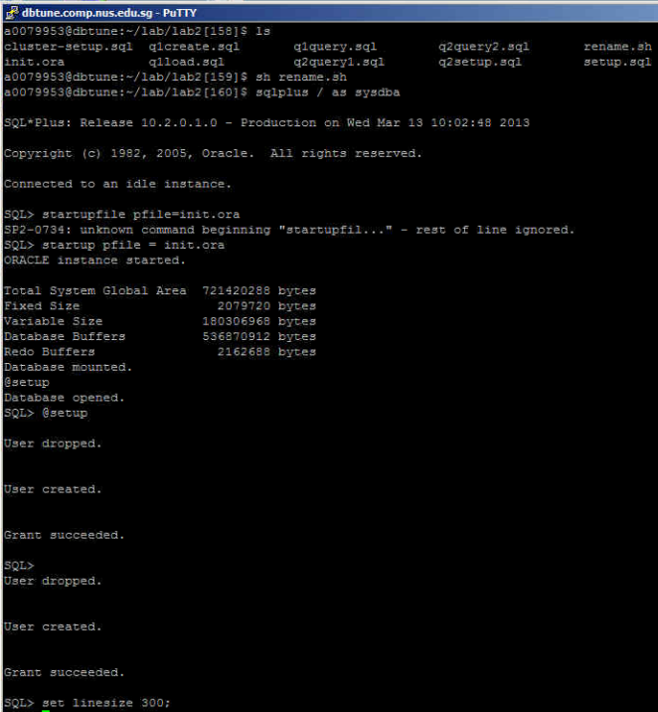

Run q1create.sql to create the table lab2user1.item

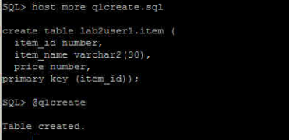

Run q1load.sql to populate the table lab2user1.item.

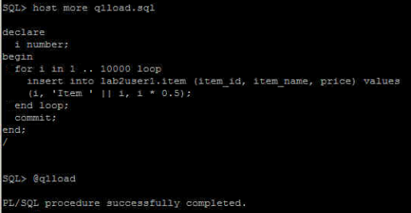
Use the set autotrace command (with the appropriate option) to determine the estimated cost of
running the query q1query.sql.

There are several parameters in the autotrace command (as below). However, since we are only interested in the execution cost and not the data nor statistics, we will use this command “set autotrace traceonly explain”

set autotrace off  set autotrace on  set autotrace traceonly  set autotrace on explain  set autotrace on statistics  set autotrace on explain statistics | set autotrace traceonly explain  set autotrace traceonly statistics  set autotrace traceonly explain statistics  set autotrace off explain  set autotrace off statistics  set autotrace off explain statistics

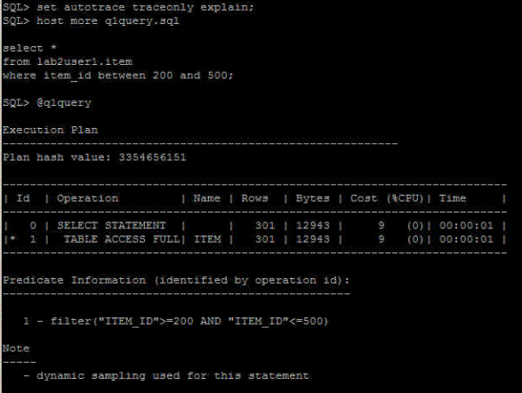
This plan shows the execution of a SELECT statement. The table was accessed using a full table scan. i.e.
- Every row in the table is accessed, and the WHERE clause criteria is evaluated for every row.
- The SELECT statement returns the rows meeting the WHERE clause criteria.

To reduce the running cost, we rebuild the table lab2user1.item as an index-organized table as follows:

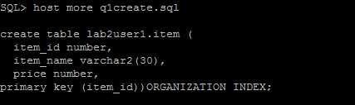

Repeat the steps above to recreate and reload the data and subsequently examine the cost of execution after an organized index is created

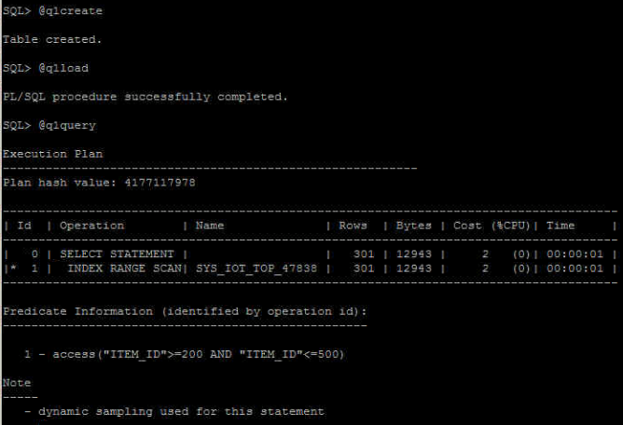

The cost of running q1query.sql has now been reduced. This plan shows execution of a SELECT statement.
- Index is used in a range scan operation to evaluate the WHERE clause criteria.
- The SELECT statement returns rows satisfying the WHERE clause conditions.

Conclusion

Index-organized tables are therefore best suited for primary key-based access and manipulation. An index-organized table is an alternative to:

Question 2: Clusters

Run q2setup.sql.

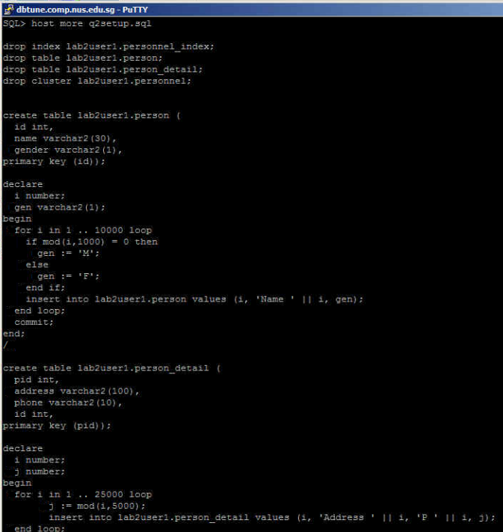
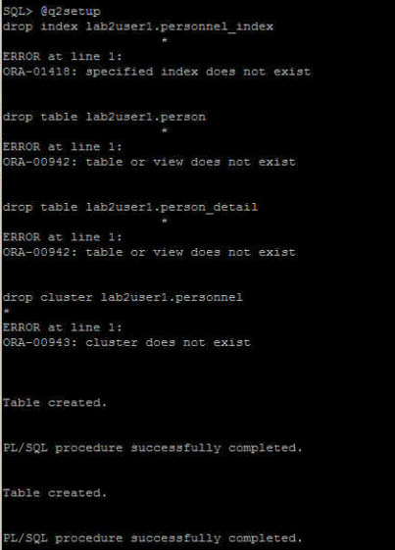
Determine the estimated cost of running the query q2query1.sql.
Determine the estimated cost of running the query q2query2.sql.
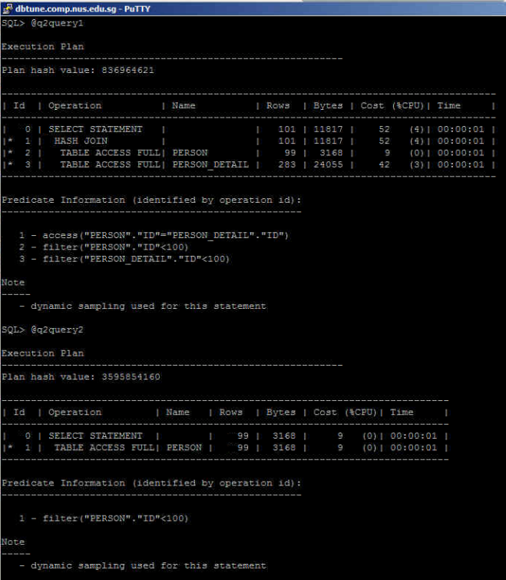
Modify cluster-setup.sql to create a cluster and a cluster index for the two tables referenced in q2query1.sql using the cluster name ’lab2user1.personnel’.

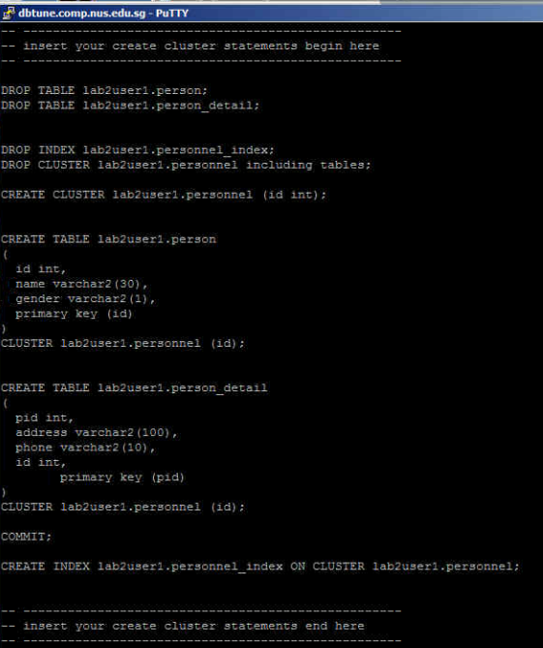
Execute modified cluster-setup.sql

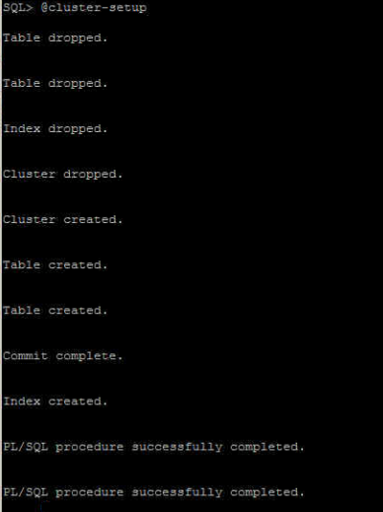

Rerun query 1 and 2 after the creation of cluster and add tables to the cluster created. The cost of the2 queries have then been reduced

